Highly contiguous genome assembly of *Drosophila prolongata* - a model for research on the evolution of sexual dimorphism and male-specific innovations

Introduction

*Drosophila prolongata* is a member of the *melanogaster* species group and *rhopaloa* subgroup native to southeast Asia (Singh & Gupta, 1977; Toda, 1991). The species has a suite of recently evolved male-specific morphological traits (Fig. 1), including increased relative foreleg size, leg pigmentation, wing pigmentation, reversed sexual size dimorphism, and an expanded number of leg chemosensory organs (D. Luecke et al., 2022; D. M. Luecke & Kopp, 2019; Luo et al., 2019). These traits are associated with derived behaviors including male-male grappling and male leg vibration courtship displays, along with divergence in sex-specific cuticular hydrocarbon profiles (Kudo et al., 2017; Luo et al., 2019; Setoguchi et al., 2014).

The phylogenetic proximity to the model species *D. melanogaster* and the availability of genome sequences for its sister species *D. rhopaloa* and *D. carrolli* (Kim et al., 2021)*,* which lack these derived traits, make *D. prolongata* a promising system to study the genetics of sexually dimorphic development, physiology, and behavior (Barmina & Kopp, 2007). A reference genome assembly and annotation for *D. prolongata* will benefit such work. Presented here is a highly complete and contiguous assembly based on long-read PacBio sequencing and Hi-C scaffolding, along with annotations for both *D. prolongata* and *D. carrolli* using *D. melanogaster* sequence homology and gene models based on RNA sequencing evidence and *ab initio* predictions.

Materials and Methods

Genome line generation

The isofemale line SaPa01 was collected in SaPa, Vietnam, on September 3, 2004 by Dr. Hisaki Takamori. Four generations of full sibling matings were carried out to produce the genomic strain SaPa_ori_Rep25-2-1-1 (“Sapa_PacBio”). Fly strains were maintained at room temperature on standard cornmeal food provided by the UC Davis Fly Kitchen with filter paper for environment structure and pupariation substrate.

Tissue collection

For genome assembly/scaffolding, adult male flies from the genome strain were moved onto plain agar food for at least one day to reduce gut microbe abundance, then collected into 1.5mL tubes and flash-frozen in liquid nitrogen. 50 frozen adult male individuals were sent on dry ice to Dovetail Genomics (Cantata Bio LLC) for DNA extraction, sequencing, and assembly. For gene expression data used in annotation, whole forelegs were dissected from carbon dioxide anesthetized males and females of the SaPa01 isofemale line, along with dissected heads from each sex of the genome strain.

Sequencing and assembly

Genomic DNA extraction, sequencing, and assembly were carried out by Dovetail Genomics. An initial assembly based on 1.2M PacBio reads was produced using FALCON (Chin et al., 2016) with Arrow polishing. A second HiRise assembly was generated with additional HiC sequencing and the HiRise software pipeline.

RNA was extracted using TRIzol (Invitrogen). For foreleg RNA, multiplexed stranded cDNA sequencing libraries were prepared using the NEBNext Ultra Directional RNA Library Prep Kit for Illumina (New England BioLabs) using poly(A) isolation magnetic beads. Libraries were sequenced on the Illumina HiSeq4000 platform by the UC Davis Genomics Center. For head RNA, cDNA sequencing libraries were constructed using the TruSeq Stranded RNA Kit (Illumina) and sequenced on the Illumina HiSeq4000 platform by Novogene (https://www.novogene.com/us-en/). Transcripts were assembled using Trinity 2.4.0 (Haas et al., 2013) with default options for stranded data.

Gene prediction and annotation

Homology-based annotations were generated using Liftoff 1.5.1 (Shumate & Salzberg, 2021) with minimap2 2.17 (Li, 2018) alignment based on the *D. melanogaster* GCF000001215.4 release 6 (Hoskins et al., 2015), *D. elegans* GCF000224195.1 2.0, and *D. rhopaloa* GCF000236305.1 2.0 (Kim et al., 2021) annotations downloaded from FlyBase (Gramates et al., 2022). Liftoff was run with the copies option and percent identity 0.80. Additional gene models were inferred using MAKER 3.01.02 (Holt & Yandell, 2011) with BLAST 2.11.0 (Camacho et al., 2009) and repeat masker 4.0.7, using EST evidence from the Trinity transcripts assembled based on leg RNA and protein homology evidence based on the combined protein sets from the *D. melanogaster* and *D. elegans* annotations also used for Liftoff. The annotations from different sources were then combined using gffcompare 10.4 (Pertea & Pertea, 2020), genometools 1.5.9 (Gremme et al., 2013), and custom Python scripts available at <https://github.com/dluecke/annotation_tools>.

Repeat analysis

Tandem repeats were annotated with Tandem Repeat Finder 4.09.1 (Benson, 1999). A de novo library of classified repetitive element models was created using RepeatModeler 2.0 (Flynn et al., 2020). Custom R and Bash scripts are available at <https://github.com/yige-luo/Repeat_analysis>.

Assembly and annotation evaluation

Assembly contiguity statistics were provided by Dovetail. Reference annotations *D. melanogaster* GCF_000001215.4 and *D. rhopaloa* GCF_018152115.1 were downloaded from the NCBI genomes database. Assembly completeness was assessed with BUSCO 5.3.2 (Manni et al., 2021) using the diptera_ocb10 lineage dataset, HMMER 3.1b2, and Mmseqs 5.34c21f2. Whole genome alignment between *D. prolongata* and *D. rhopaloa* assemblies was performed with MUMmer 4.0.0 (Marçais et al., 2018) using nucmer alignment with a minimum exact match 1000bp for alignment with *D. rhopaloa* and 500bp for *D. melanogaster* alignment,and mummerplot for visualization. Annotation statistics were found with genometools 1.5.9 (Gremme et al., 2013). Transcripts were extracted from annotations using gffread 0.9.12 (Pertea & Pertea, 2020), and transcript completeness was assessed using the transcriptome mode of BUSCO.

Results and discussion

Assembly contiguity

The Dovetail HiRise assembly scaffolding method (Fig 2) produced an assembly for *D. prolongata* with higher contiguity than the existing *D. rhopaloa* assembly, approaching the contiguity of the latest *D. melanogaster* reference (Table 1) as measured by N50 or N90. Whole genome alignments between the *D. prolongata* assembly and *D. rhopaloa* and *D. melanogaster* reference genomes (Fig 3a) show long stretches of high identity with *D. rhopaloa* spanning nearly all large scaffolds.

|  |  |  |  |  |
| --- | --- | --- | --- | --- |
| **Assembly** | *prolongata* | *carrolli* | *rhopaloa* | *melanogaster* |
| **Total length (bp)** | 223340102 | 231219246 | 193508231 | 143726002 |
| **Scaffolds** | 414 | 338 | 228 | 1870 |
| **N50 (bp)** | 22190000 | 14004682 | 15806012 | 25286936 |
| **L50** | 4 | 5 | 5 | 3 |
| **GC%** | 40.11% | 39.52% | 39.87% | 41.67% |
| **BUSCO Complete, Single Copy** | 92.4% (3036) | 97.8% (3214) | 98.1% (3221) | 98.5% (3235) |
| **BUSCO Complete, Duplicated** | 6.1% (200) | 0.4% (13) | 0.4% (12) | 0.2% (8) |
| **BUSCO Fragmented** | 0.9% (29) | 0.6% (19) | 0.7% (24) | 0.5% (16) |
| **BUSCO Missing** | 0.6% (20) | 1.2% (39) | 0.8% (28) | 0.8% (26) |

Table 1: Statistics for assembly contiguity and completeness of *D. prolongata* assembly alongside previously published *D. carrolli* GCA_018152295.1 assembly andreference assemblies *D. rhopaloa* GCF_018152115.1 and *D. melanogaster* GCF_000001215.4. BUSCO statistics are for the 3285 genes in the diptera_odb10 benchmark set.

Assembly completeness

BUSCO results for assemblies (Table 1) show a comparable degree of completeness for the 3285 genes in the BUSCO dipteran benchmark set between *D. prolongata* assembly and the reference genomes of sibling species, with 3236 complete for *D. prolongata*, 3233 complete for *D. rhopaloa*, and 3243 complete for *D. melanogaster*. The whole genome alignments between the *D. prolongata* assembly and the *D. rhopaloa* and *D. melanogaster* references (Fig 3) further show near complete highly contiguous coverage of the entire reference with regions of *D. prolongata* scaffolds, corresponding to all five major chromosome arms in the *D. melanogaster* genome.

Repeat annotation

The *D. prolongata* genome is moderately repetitive, with transposable elements and simple repeats comprising about 13% of its sequence, of which 38.4% are tandem repeats and 28.3% are LTR retrotransposons (Table S1).

|  |  |
| --- | --- |
| **Repeat group** | **% of the genome** |
| DNA transposons | 0.45% |
| Non-LTR retrotransposons (LINEs) | 1.53% |
| LTR retrotransposons | 3.68% |
| SINEs | 0% |
| Low complexity and simple repeats | 0.01% |
| Rolling Circle Transposon (RC) | 0.75% |
| Unknown class TE | 1.55% |
| Tandem repeats by TRF | 5.05% |
| **Total** | **13.02%** |

Supplementary Table 1: Repeat content of *D. prolongata* genome assembly

Annotation completeness

Transcripts extracted from the annotation and assembly show a high degree of completeness for the *D. prolongata* and *D. carrolli* annotations. However, they do not match the completeness of the *D. rhopaloa* and especially *D. melanogaster* references (Table 2), both in terms of gene inclusion and completeness of individual gene models. A higher number of BUSCO dipteran benchmark genes are missing in the *D. prolongata* (82) and *D. carrolli* (115) annotationscompared to the *D. rhopaloa* (15) or *D. melanogaster* (0) references. Additionally, the transcripts in the *D. prolongata* and *D. carrolli* annotationsare shorter than those from the references, and many more BUSCO dipteran benchmark genes are fragmented in the *D. prolongata* (110) and *D. carrolli* (89) annotations than for the *D. rhopaloa* and *D. melanogaster* references (3 each). These statistics show the limitations of current algorithmic annotation methods and indicate that care should be used when using gene models from these draft annotations. Despite these limitations, the overall completeness is quite high, with 94.2% and 93.8% of BUSCO benchmark genes covered by *D. prolongata* and *D. carrolli* annotations,and reasonable median transcript lengths in both. These resources will provide a good foundation for future genetic studies in *D. prolongata* and relatives when used with the limitations of draft annotations in mind, and future iterations of the annotations should aim to improve gene model coverage and completeness.

|  |  |  |  |  |
| --- | --- | --- | --- | --- |
| **Annotation** | *prolongata* | *carrolli* | *rhopaloa* | *melanogaster* |
| **Genes** | 19570 | 16346 | 15463 | 17559 |
| **Protein Coding Genes** | 16383 | 13159 | 14607 | 13986 |
| **Exons** | 180792 | 168247 | 154625 | 190719 |
| **Median Transcript Length (bp)** | 1636 | 1758 | 1995 | 1954 |
| **Longest Transcript (bp)** | 63866 | 63847 | 65859 | 71382 |
| **BUSCO Complete** | 94.2% (3093) | 93.8% (3081) | 99.4% (3267) | 99.9% (3282) |
| **BUSCO Fragmented** | 3.3% (110) | 2.7% (89) | 0.1% (3) | 0.1% (3) |
| **BUSCO Missing** | 2.5% (82) | 3.5% (115) | 0.5% (15) | 0.0% (0) |

Table 2: Statistics for annotation completeness for *D. prolongata* and *D. carrolli* annotations alongside reference annotations *D. rhopaloa* GCF_018152115.1 and *D. melanogaster* GCF_000001215.4. BUSCO statistics are for the 3285 genes in the diptera_odb10 benchmark set.

Potential regional duplication

The other major caveat for this assembly and annotation is the extent of identified duplication. This stands out most clearly in the *D. prolongata* assembly BUSCO scores, where 200 benchmark single-copy genes were identified as duplicated compared to 12 for *D. rhopaloa* and 8 for *D. melanogaster*. Additional signatures of duplicated regions are also visible. The total length of the draft assembly is higher than either reference (Table 1), as is the total number of genes in the annotation (Table 2). This suggests that some regions are represented more than once. Some regions of potential duplication are also visible in the whole genome alignment (Fig 3). Identifying and removing duplicate scaffolds is a clear avenue of improvement for future iterations of this genomic reference.

Literature cited

Barmina, O., & Kopp, A. (2007). Sex-specific expression of a HOX gene associated with rapid morphological evolution. *Developmental Biology*, *311*(2), 277–286. https://doi.org/10.1016/j.ydbio.2007.07.030

Benson, G. (1999). Tandem repeats finder: A program to analyze DNA sequences. *Nucleic Acids Research*, *27*(2), 573–580. https://doi.org/10.1093/nar/27.2.573

Camacho, C., Coulouris, G., Avagyan, V., Ma, N., Papadopoulos, J., Bealer, K., & Madden, T. L. (2009). BLAST+: Architecture and applications. *BMC Bioinformatics*, *10*, 1–9. https://doi.org/10.1186/1471-2105-10-421

Chin, C.-S., Peluso, P., Sedlazeck, F. J., Nattestad, M., Concepcion, G. T., Clum, A., Dunn, C., O’Malley, R., Figueroa-Balderas, R., Morales-Cruz, A., Cramer, G. R., Delledonne, M., Luo, C., Ecker, J. R., Cantu, D., Rank, D. R., & Schatz, M. C. (2016). Phased diploid genome assembly with single-molecule real-time sequencing. *Nature Methods*, *13*, 1050. http://dx.doi.org/10.1038/nmeth.4035

Flynn, J. M., Hubley, R., Goubert, C., Rosen, J., Clark, A. G., Feschotte, C., & Smit, A. F. (2020). RepeatModeler2 for automated genomic discovery of transposable element families. *Proceedings of the National Academy of Sciences of the United States of America*, *117*(17), 9451–9457. https://doi.org/10.1073/pnas.1921046117

Gramates, L. S., Agapite, J., Attrill, H., Calvi, B. R., Crosby, M. A., dos Santos, G., Goodman, J. L., Goutte-Gattat, D., Jenkins, V. K., Kaufman, T., Larkin, A., Matthews, B. B., Millburn, G., & Strelets, V. B. (2022). FlyBase: a guided tour of highlighted features. *Genetics*, *220*(4). https://doi.org/10.1093/genetics/iyac035

Gremme, G., Steinbiss, S., & Kurtz, S. (2013). Genome tools: A comprehensive software library for efficient processing of structured genome annotations. *IEEE/ACM Transactions on Computational Biology and Bioinformatics*, *10*(3), 645–656. https://doi.org/10.1109/TCBB.2013.68

Haas, B. J., Papanicolaou, A., Yassour, M., Grabherr, M., Philip, D., Bowden, J., Couger, M. B., Eccles, D., Li, B., Macmanes, M. D., Ott, M., Orvis, J., Pochet, N., Strozzi, F., Weeks, N., Westerman, R., William, T., Dewey, C. N., Henschel, R., … Regev, A. (2013). De novo transcript sequence recostruction from RNA-Seq: reference generation and analysis with Trinity. In *Nature protocols* (Vol. 8, Issue 8). https://doi.org/10.1038/nprot.2013.084.De

Holt, C., & Yandell, M. (2011). MAKER2: An annotation pipeline and genome-database management tool for second-generation genome projects. *BMC Bioinformatics*, *12*(1). https://doi.org/10.1186/1471-2105-12-491

Hoskins, R. A., Carlson, J. W., Wan, K. H., Park, S., Mendez, I., Galle, S. E., Booth, B. W., Pfeiffer, B. D., George, R. A., Svirskas, R., Krzywinski, M., Schein, J., Accardo, M. C., Damia, E., Messina, G., Méndez-Lago, M., De Pablos, B., Demakova, O. V., Andreyeva, E. N., … Celniker, S. E. (2015). The Release 6 reference sequence of the Drosophila melanogaster genome. *Genome Research*, *25*(3), 445–458. https://doi.org/10.1101/gr.185579.114

Kim, B. Y., Wang, J. R., Miller, D. E., Barmina, O., Delaney, E., Thompson, A., Comeault, A. A., Peede, D., D’agostino, E. R. R., Pelaez, J., Aguilar, J. M., Haji, D., Matsunaga, T., Armstrong, E. E., Zych, M., Ogawa, Y., Stamenković-Radak, M., Jelić, M., Veselinović, M. S., … Petrov, D. A. (2021). Highly contiguous assemblies of 101 drosophilid genomes. *ELife*, *10*, 1–33. https://doi.org/10.7554/eLife.66405

Kudo, A., Shigenobu, S., Kadota, K., Nozawa, M., Shibata, T. F., Ishikawa, Y., & Matsuo, T. (2017). Comparative analysis of the brain transcriptome in a hyper-aggressive fruit fly, <i>Drosophila prolongata</. *Insect Biochemistry and Molecular Biology*, *82*, 11–20. https://doi.org/10.1016/j.ibmb.2017.01.006

Li, H. (2018). Minimap2: Pairwise alignment for nucleotide sequences. *Bioinformatics*, *34*(18), 3094–3100. https://doi.org/10.1093/bioinformatics/bty191

Luecke, D. M., & Kopp, A. (2019). Sex-specific evolution of relative leg size in *Drosophila prolongata* results from changes in the intersegmental coordination of tissue growth. *Evolution*, *73*(11), 2281–2294. https://doi.org/10.1111/evo.13847

Luecke, D., Rice, G., & Kopp, A. (2022). Sex-specific evolution of a *Drosophila* sensory system via interacting *cis*- and *trans*-regulatory changes. *Evolution and Development*, *24*(1–2), 37–60. https://doi.org/10.1111/ede.12398

Luo, Y., Zhang, Y., Farine, J. P., Ferveur, J. F., Ramírez, S., & Kopp, A. (2019). Evolution of sexually dimorphic pheromone profiles coincides with increased number of male-specific chemosensory organs in *Drosophila prolongata*. *Ecology and Evolution*, *9*(23), 13608–13618. https://doi.org/10.1002/ece3.5819

Manni, M., Berkeley, M. R., Seppey, M., Simão, F. A., & Zdobnov, E. M. (2021). BUSCO Update: Novel and Streamlined Workflows along with Broader and Deeper Phylogenetic Coverage for Scoring of Eukaryotic, Prokaryotic, and Viral Genomes. *Molecular Biology and Evolution*, *38*(10), 4647–4654. https://doi.org/10.1093/molbev/msab199

Marçais, G., Delcher, A. L., Phillippy, A. M., Coston, R., Salzberg, S. L., & Zimin, A. (2018). MUMmer4: A fast and versatile genome alignment system. *PLoS Computational Biology*, *14*(1), 1–14. https://doi.org/10.1371/journal.pcbi.1005944

Pertea, G., & Pertea, M. (2020). GFF Utilities: GffRead and GffCompare [version 2; peer review: 3 approved]. *F1000Research*, *9*(304), 1–20. https://f1000research.com/articles/9-304/v2

Setoguchi, S., Takamori, H., Aotsuka, T., Sese, J., Ishikawa, Y., & Matsuo, T. (2014). Sexual dimorphism and courtship behavior in *Drosophila prolongata*. *Journal of Ethology*, *32*, 91–102. https://doi.org/10.1007/s10164-014-0399-z

Shumate, A., & Salzberg, S. L. (2021). Liftoff: Accurate mapping of gene annotations. *Bioinformatics*, *37*(12), 1639–1643. https://doi.org/10.1093/bioinformatics/btaa1016

Singh, B., & Gupta, J. (1977). Two new and two unrecorded species of the genus *Drosophila* Fallen (Diptera: Drosophilidae) from Shillong, Meghalaya, India. *Proceedings of the Zoological Society (Calcutta)*, *30*, 31–38.

Toda, M. J. (1991). Drosophilidae (Diptera) in myanmar (Burma) VII. The *Drosophila melanogaster* species-group, excepting the *D. montium* species-subgroup. *Oriental Insects*, *25*(1), 69–94. https://doi.org/10.1080/00305316.1991.10432216

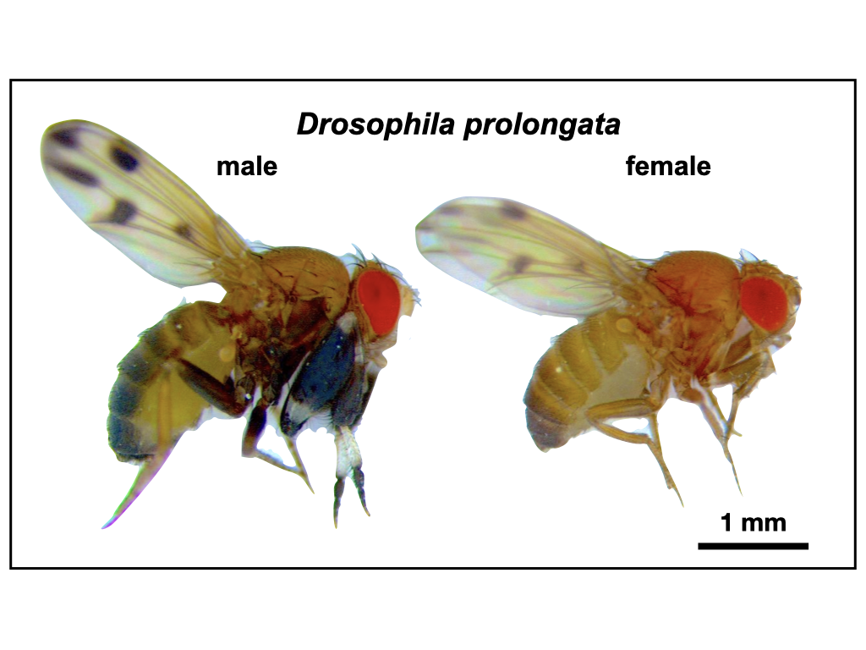

Figure 1: *Drosophila prolongata* has a suite of recently evolved male-specific traits, ideal for studying the evolution of sexual dimorphism. Most noticeable is the size and pigmentation banding of front legs in males. Other sexually dimorphic characteristics include wing spots, eye shape, pigmentation, and increased length of second and third legs.



Figure 2: Dovetail assembly process generates high contiguity assembly. Comparison between initial PacBio FALCON with Arrow polished assembly (“Input Assembly”) and final assembly generated by Dovetail HiC scaffolding method (“HiRise Assembly”), provided by Dovetail genomics. Each curve shows the fraction of total length of the assembly in scaffolds of a given length or smaller. Scaffolds less than 1kb are excluded.



Figure 3: Whole genome alignments between all scaffolds of *D. prolongata* assembly and reference assemblies. (A) Alignment to *D. rhopaloa* based on minimum 1000bp matches, showing all reference scaffolds as ordered in assembly. (B) Alignment to major chromosome arms from *D. melanogast*er assembly, based on minimum 500bp matches. Forward matches are shown in purple and reverse matches in blue.